Notice d’utilisation

Python script:

REQUIREMENTS:
To use the script that analyze a TCPDump file, you must have downloaded the MarkDown library with the command “pip install markdown” or “python -m pip install markdown”. Of course, you must have Python installed

The script is simple to use, but you must have checked that you downloaded it and the TCPDump file, then you open the python file and go all the way down here:

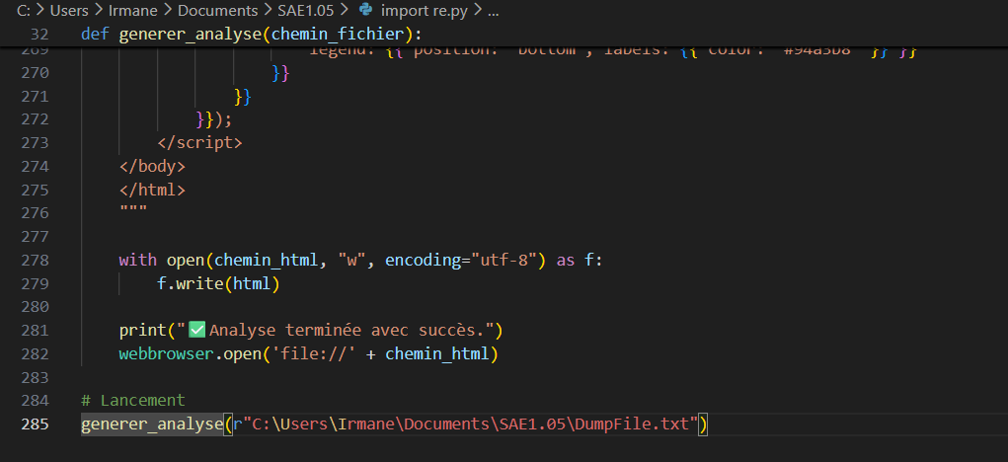
You have almost finished the job already, you must change the last line by the emplacement of your TCPDump file, mine is named DumpFile.txt in my Documents.

Once you did that, run the script:
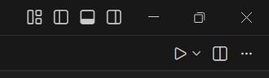
And your browser will opend a “.html” file generated by the script where you can choose which file you want to see:
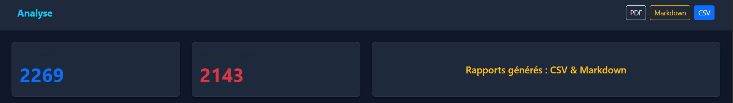
There are also statistics under about the events on the TCPDump file.

Excel:
REQUIREMENTS:
- Excel
First, click on the “CSV” button on the html page:
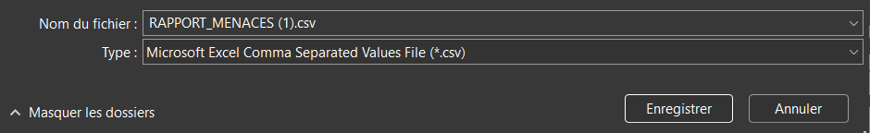
It will then ask you where you want to download it. Download it and then open it.
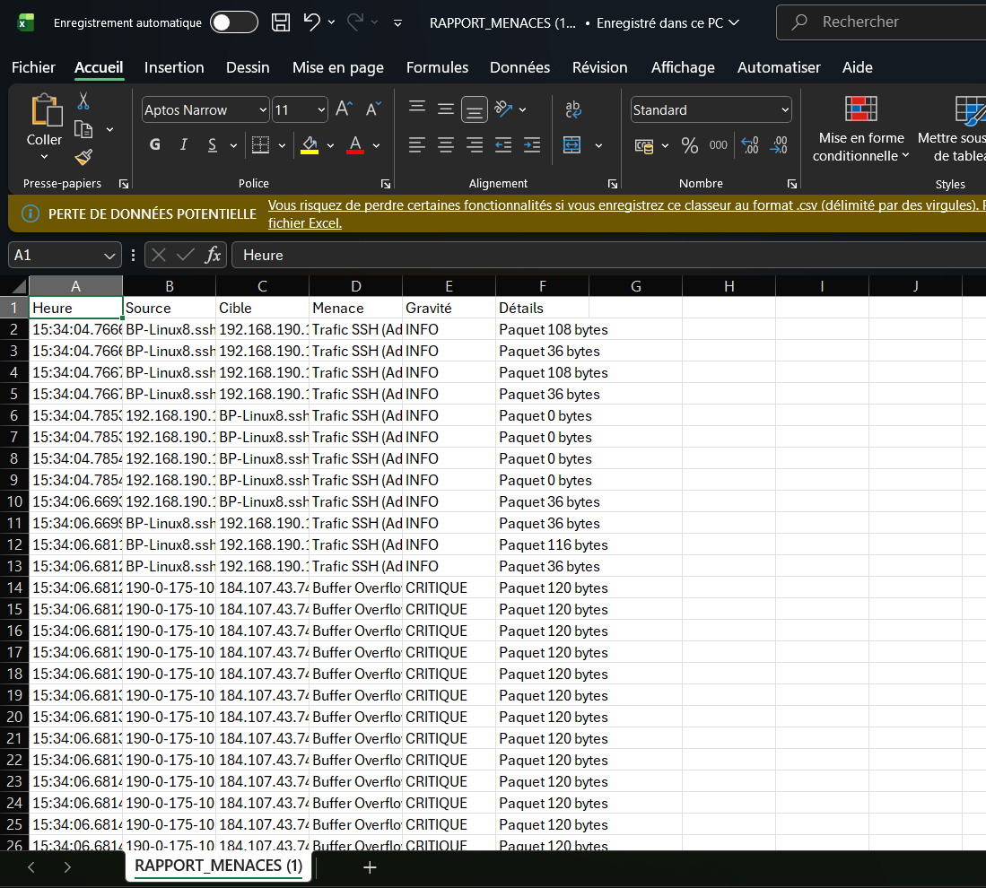
Next step, on “INSERTION” and “recommended graphics”
This will appear:
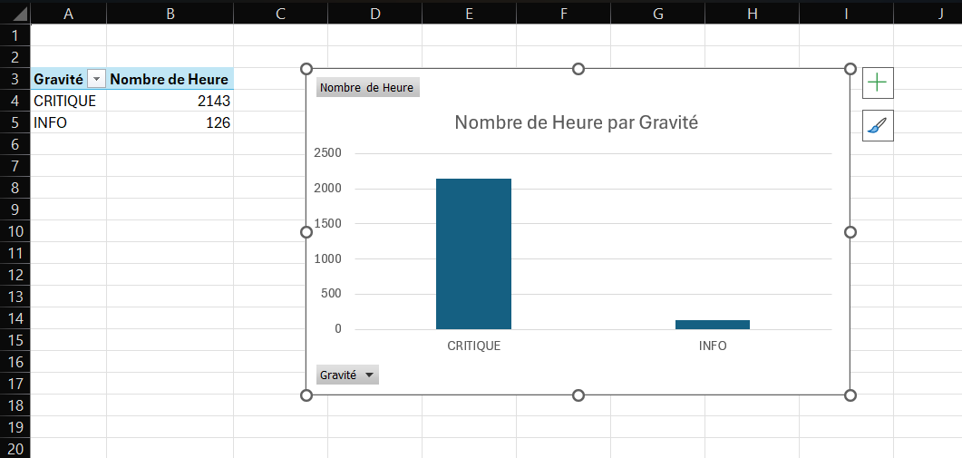
Now look on the right of the application and select “menace”:
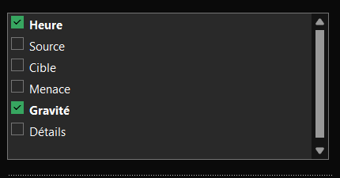
Now your graphics should look like that:
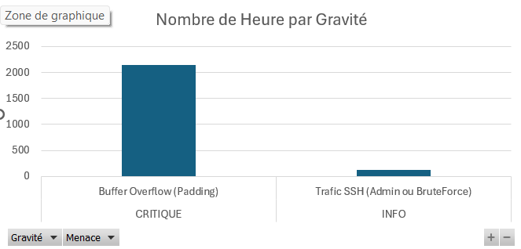

Now you know everything to use these tools.

